WRRB COVID-19 EXPOSURE
CONTROL PLAN

Contents
Exposure Control Plan 2
Background 2
Returning to the Office 2
COVID-19 Workplace Risk Assessment 2
Hazards and Mitigation 3
Person to Person Contact 3
Workplace Equipment 4
Environment 5
Routine Cleaning 6
COVID-19 Worker Hazard Assessment 6
WRRB Office 6
Another Jobsite 7
Shared Vehicles 7
Board Meetings 7
Reversion of the Public Health Emergency 7
Suspected Exposure 7
Training 7
Short Term Monitoring 8
Appendix A: Completed Workplace Risk Assessment 9
Appendix B: Board Meeting Safety 10
Appendix C: Ground Vehicle Safety Guidelines 11
Appendix D: Routine Cleaning List 14
Appendix E: Covid-19 Worker Hazard Assessment 16

Exposure Control Plan

Background

The WRRB will follow workplace safety and public health requests and recommendations given by the Chief Public Health Officer for the Northwest Territories regarding public health risks.

The Executive Director will use the most current information from the Government of Canada, the Government of the Northwest Territories (GNWT), and from the Chief Public Health Officer for the Northwest Territories to determine when actions will be taken in response to a public health risk.

On March 18, 2020, the Chief Public Health Officer declared a public health emergency in response to the COVID-19 Pandemic. On May 15, 2020, the NWT entered Phase 1 of the Emerging Wisely Plan, and on June 12, 2020 the NWT entered Phase 2. The GNWT’s Emerging Wisely Plan outlines a phased approach to slowly lifting restrictions on residents, businesses, and society in the Northwest Territories.

Returning to the Office

WRRB Staff began working from home when a public health emergency was declared in the Northwest Territories, including in Phase 1 of the Emerging Wisely Plan. WRRB Procedure for this is outlined in the WRRB Epidemic Disease Initial Response Plan.

As measures from the Emerging Wisely Plan were fully implemented and there were no active cases of COVID-19 in the NWT, the NWT entered Phase 2 of the Emerging Wisely Plan, permitting a relaxation of some protective measures. The WRRB office will be able to open to WRRB staff in Phases 2 and 3 of the public health response, following the mitigation measures outlined in this document. This document was created with input from all WRRB staff. The WRRB office will remain closed to the public during the public health emergency.

All Staff have the right to refuse unsafe work by reporting to the Executive Director during regular staff check-ins. No staff are required to come to the office to work during the Public Health Emergency and can work from home. Should the Public Health Emergency end, all Staff will be required to return to work. However, Staff may request to work from home following the end of the Public Health Emergency, on a case-by-case basis.

COVID-19 Workplace Risk Assessment

A Workplace Risk Assessment was completed in consultation with Board Staff and is attached as Appendix A. Workers’ Safety & Compensation Commission (WSCC) NT provided the Risk Assessment as a tool for employers to identify what safety measures and procedures need to be in place to reopen and safely run a workplace.

Hazards and Mitigation

The hazards and control methods listed below are intended to protect WRRB Staff through their work at the WRRB Office. Hazards and controls for Board Staff and Board Members at in person Board Meetings will be separately outlined in the future Appendix B: Board Meetings During a Public Health Emergency.

WRRB procedures for Phase 1 of the Emerging Wisely Plan are covered in the WRRB’s Epidemic Response Plan, which includes cancelled board meetings and working from home.
In Phase 4, when either a vaccine is broadly available for use in the NWT or an effective treatment is established, this plan will not longer be active as the NWT will no longer be in a Public Health Emergency.

Person to Person Contact

Hazard | Phase 2 Control Methods | Phase 3 Control Methods
Board Staff | Work from home two days a week. Minimum 2-meter distance at all times between staff when in the office. | Work in office each day. Maintain 2-meter distance at all times between staff.
Board Members | Minimize Board Meetings when possible. In-person meetings will be held off site. See Appendix B for Board Meeting control methods. | Minimize Board Meetings when possible. In-person meetings will be held off site. See Appendix B for Board Meeting control methods.
Non WRRB Colleagues | Online Meetings, Emails, Phone Calls | Online meetings, emails, phone calls. Small meetings (maximum 6 people) can be held in the board room, maintaining 2-meter distance between persons. Guests must follow other hazard control methods as identified in the plan.
General Public | Office closed to the public. Doors are locked. | Office closed to the public. Doors are locked

Workplace Equipment

Generally, in Phase 2, objects or parts of objects touched by a person should be sanitized, and hands should be washed, after contact with that item. In Phase 3, it will only be necessary to clean your hands after touching a shared object or surface. Routine cleaning of all objects in the office will persist through both Phase 2 and Phase 3.

Hazard | Phase 2 Control Methods | Phase 3 Control Methods
Shared Printer/Copier | Limit touch of printer when possible (scan and print via touchless). Clean the surfaces of the device that you touch with disinfectant after every use. Wash your hands after using the printer/copier. | Limit touch of printer when possible (scan and print via touching less). Wash your hands after using the printer/copier.
Shared electronics (Remotes, conference phone) | Limit sharing of devices. Clean shared devices after use and wash your hands. Wear gloves when using shared touch screen devices that cannot be disinfected. | Limit sharing of devices. Wash hands after use. Wear gloves when using shared touch screen devices that cannot be disinfected.
Paper Shredder | Limit touch of the paper shredder when possible (leave it on and insert paper without touching the machine). Clean the surfaces of the device that you touch with disinfectant after every use. Wash your hands after using the shredder if you touched it. | Limit touch of the paper shredder when possible (leave it on and insert paper without touching the machine). Wash your hands after using the shredder if you touched it.

Environment

In both Phases 2 and 3, Staff are not permitted to share desk spaces. If Staff need an object from another desk space, it must be sanitized before it is shared.

Hazard | Phase 2 Control Methods | Phase 3 Control Methods
Washroom | After use, clean the toilet handle, toilet paper holder, sink taps and dials and anything else you have touched. Wash your hands before leaving the washroom | Wash your hands after using the washroom.
Fridge | Minimize use of the fridge. Do not touch another person’s food. Food must be in packaging and not loose edible portions. Clean the fridge door after contact. Wash your hands after touching the fridge. | Do not touch another person’s food. Food must be in packaging and not loose edible portions. Wash your hands after touching the fridge.
Dishes/Cutlery/Cups | No sharing of dishes, cutlery, or cups. Keep a set at your desk and wash after each use. Do not leave dirty items for others to clean. After washing, sanitize areas of the sink or counter that you touched. | No sharing of dishes, cutlery, or cups. Keep a set at your desk and wash after each use. Do not leave dirty items for others to clean. After washing, sanitize areas of the sink or counter that you touched.
Front Door | The front door to the office will remain locked. Wash your hands after touching doorknobs. Doorknob to be sanitized after use. | The front door to the office will remain locked. Wash your hands after touching doorknobs.
Coat Closet | Avoid use of shared coat closet by keeping personal items near your desk. | Avoid use of shared coat closet by keeping personal items near your desk.
Kettle, Coffee Grinder and Coffee Pot | Kettle and coffee pot handles and other parts must be cleaned after each use. Clean hands after use. | Kettle and coffee pot handles and other parts must be cleaned after each use. Clean hands after use.
Water Cooler | Prior to use, a cup/mug/water bottle must be washed. All parts must be cleaned after each use. Clean hands after use. | Prior to use, a cup/mug/water bottle must be washed. All parts must be cleaned after each use. Clean hands after use.
Toaster Oven/Microwave | Touched areas of the toaster oven/microwave must be cleaned between each use. Wash your hands after use. | Wash your hands after use of the toaster oven/microwave.
Compost Bucket | Touched areas of the compost bucket must be cleaned after each use. Clean hands after use. Bucket must be emptied once a week. | Wash your hands after use of compost bucket. Bucket must be emptied once a week.
Recycling Centre | Touched areas of the recycling containers must be cleaned after each use. Clean hands after use. Recycling must be emptied every two weeks. | Wash your hands after use of the recycling centre. Recycling must be emptied every two weeks.
Dish Cloth | Disposable J-Cloths will be used for washing dishes. Wash hands after use of dish cloth. Cloth must be replaced every two days. | Disposable J-Cloths will be used for washing dishes. Wash hands after use of dish cloth. Cloth must be replaced every two days.

Routine Cleaning

In Phase 2, high touch areas of the office will be cleaned 2 times a day (1:00 pm and 4:45 pm). This is in addition to cleaning due to use or contact.

In Phase 3, high touch areas of the office will be cleaned 1 time a day (4:45 pm). This is in addition to cleaning due to use or contact.

There will be a log posted online where staff can initial and date/time when cleaning has occurred. See Appendix D for the routine cleaning list and log.

Cleaning must employ a disinfectant listed on Health Canada’s list of approved products. It is recommended paper towel and a disinfectant be used whenever possible, to minimise use of disposable disinfectant wipes, which are difficult to acquire.

In Phase 3, a contractor wearing a mask is permitted to complete any portion of the routine cleaning list.

COVID-19 Worker Hazard Assessment

WRRB Office

Before working in the office for the first time, each Staff member must complete the WSCC document ‘Covid-19 Worker Hazard Assessment’, printed as Appendix E in this document. Each completed Assessment must be submitted to the Executive Director who will store the files.

If there are uncontrolled hazards in the workplace identified through the Hazard Assessment, the Executive Director will work with staff to control the hazards.

Another Jobsite

If any WRRB Staff perform work at another jobsite (not their homes), another Worker Hazard Assessment must be completed (Appendix E). Fieldwork, such as the Boots on the Ground program, must have its own plan to ensure the safety of WRRB Staff.

Completed Worker Hazard Assessments must be submitted to the Executive Director.

Shared Vehicles

WRRB Staff will follow the GNWT Document “Ground Vehicle Safety Guidelines and Checklists,” which is attached as Appendix C, for travel in a shared vehicle. The Board will provide staff with the required PPE.

Board Meetings

Board Meetings will be cancelled, delayed, and shortened wherever possible. If a Board Meeting must occur during the COVID-19 Pandemic, Appendix B will be followed to permit as safe a meeting as possible.

Reversion of the Public Health Emergency

If the Emerging Wisely Plan reverts to Phase 1, WRRB staff will work from home until the NWT is in Phase 2. Reversion from Phase 3 to Phase 2 will require Staff and Board Members to follow the hazards and mitigations table for the Phase they are currently in.

Suspected Exposure

If you believe you have been exposed to COVID-19 or are in close contact with someone who believes they may have been exposed, do not come into the office and call the Yellowknife Public Health Clinic for advice on how to proceed. Inform the Executive Director of your suspected exposure.

Training

Staff are required to read this Exposure Control Plan before they are permitting to resume work in the WRRB office.

Additional training includes viewing the following:
- Healthy Respiratory Practices https://www.hss.gov.nt.ca/sites/hss/files/resources/healthy-respiratory-practices.pdf

- Social Distancing https://www.gov.nt.ca/covid-19/en/services/social-distancing
- Non-Medical Mask Use https://www.canada.ca/en/public-health/services/publications/diseases-conditions/covid-19-safely-use-non-medical-mask-face-covering.html
- Mental Health and Social Distancing https://www.gov.nt.ca/covid-19/en/mental-health

Short Term Monitoring

Every two weeks from when the WRRB office reopen, Staff will have a meeting to discuss the implementation of this plan. Discussions will include:

- Do all workers understand the administrative processes and procedures?
- Are administrative procedures being followed? If not, why not?
- Are the current methods for separating workers from potential exposure working? If not, how
can they be better?
- Is personal protective equipment functional, and does everyone understand how to use it correctly? If not, what is needed or what changes should be made?
- Has the training met the needs for the workers? Is there other training they need?
- Do workers have any concerns? Have they identified new sources of exposure to the virus? Ask
them what processes and procedures are working or not working for them?

Appendix A: Completed Workplace Risk Assessment

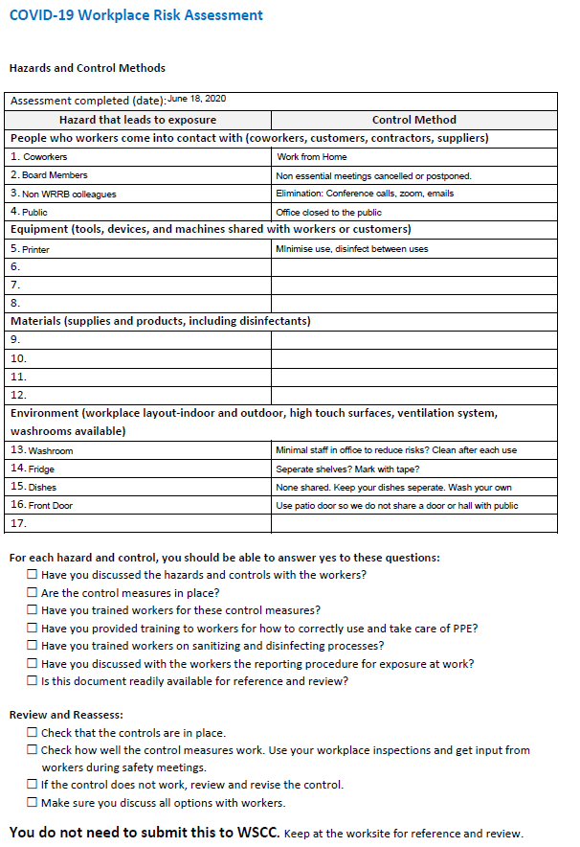

Appendix B: Board Meeting Safety

Board meetings will be held in-person in Yellowknife only during Phase 2 and 3. Virtual options will be provided for attendance. Meetings will be kept as short as possible to conduct business but keep Members safe.

Travel from communities will be via air charter or scheduled flight, depending on existing Covid-19 protocols at the time. Travel days will be no more than one day prior to or after the meeting date(s). Members will be provided accommodations, as per the WRRB’s Operating Procedures Manual.

Board meetings will be held off site from the WRRB board room during Phase 2 and 3. The meeting space must be large enough to follow Covid-19 protocols.

Microphones must be provided to allow distancing but ensure adequate hearing. Interpreters must be provided sound booths to ensure distancing.

Members must wear masks until seated at their table. Masks and hand sanitizer will be provided. Staff that assist Members with their tablet must wear masks and gloves.

Catering, including coffee service and food, must be individually packaged.

Guests will attend in-person or via a virtual option. If attending in-person, the guest must distance and wear a mask.

Appendix C: Ground Vehicle Safety Guidelines

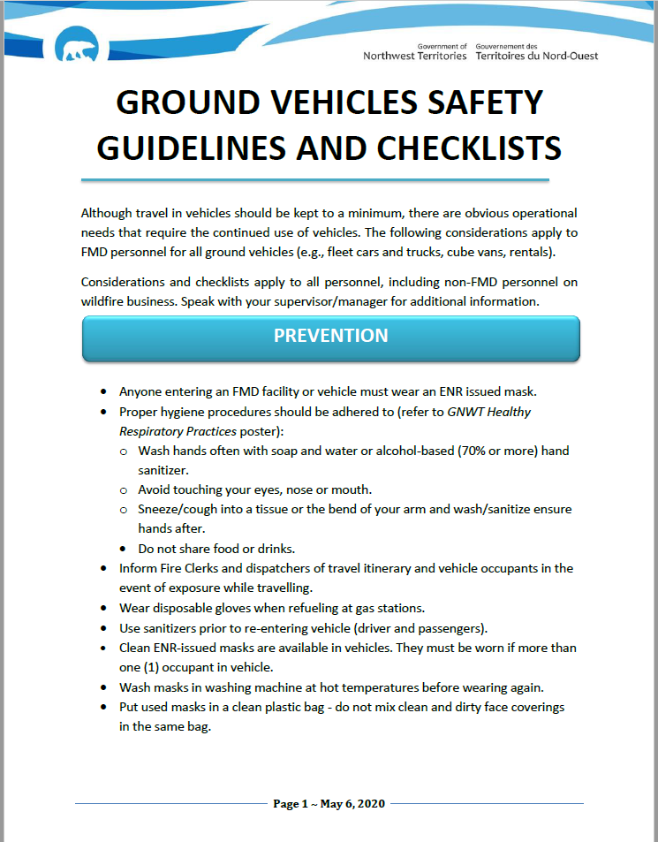
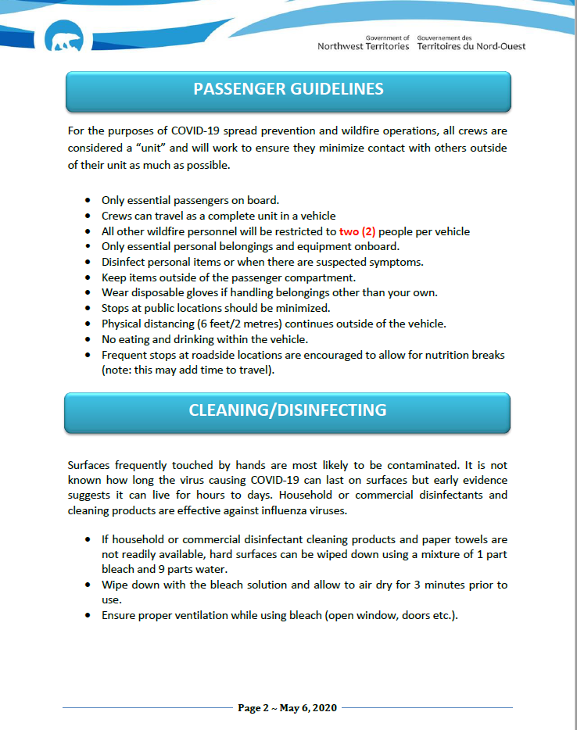

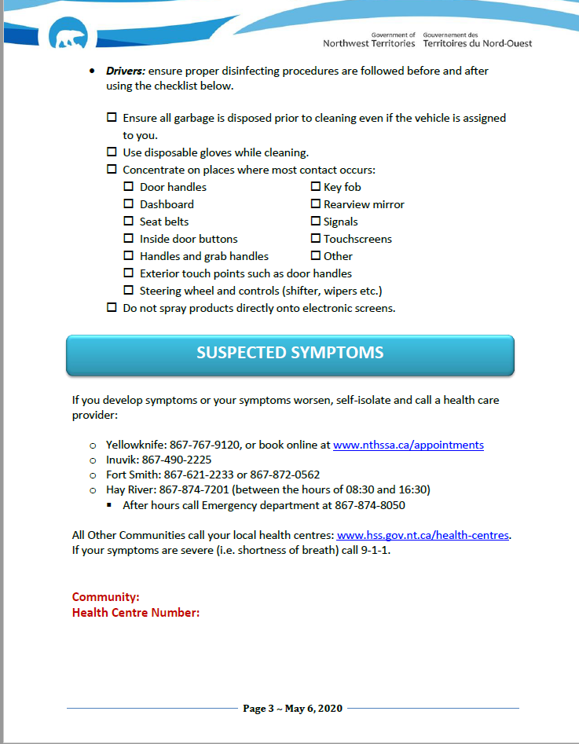

Appendix D: Routine Cleaning List

Checklist
Date/Time
Front door handles, door push area
Bathroom door handles, door push area
Bathroom sink, faucet and taps
Toilet activator
Toilet paper holder
Kitchen sink, faucet and taps
Dish soap
Kitchen counter
Kitchen handles
Microwave/toaster oven
Fridge
Recycling Centre
Compost bucket
Printer
Shredder
Conference Phone
Board room door handle
Board chairs
Board table
Board kitchen sink, faucet and taps
Board kitchen counter
Board kitchen handles
Quiet room door handle
Quiet room chairs
Quiet room table
Light Switches

Appendix E: Covid-19 Worker Hazard Assessment

https://www.wscc.nt.ca/sites/default/files/documents/COVID-19%20Worker%20Hazard%20Assessment%20-%20EN%20fillable.pdf

