Northwest Territories
Wildlife Research Permit Application Form
Applicant: James Hodson, ENR, Wildlife Division
Address: Department of Environment and Natural Resources
Government of the Northwest Territories
P.O. Box 1320, Yellowknife, NT X1A 2L9
Phone: (867) 767-9237 ext. 53227 Fax: (867) 873-0293
Email: james_hodson@gov.nt.ca

Sponsor(s): Environment and Natural Resources, GNWT
Funding Sources: Environment and Natural Resources and Department of Infrastructure GNWT

Additional Licenses Required: NWT Wildlife Care Committee Permit
Project Title: Boreal caribou collar deployment and spring classification surveys for the Tłı̨chǫ All-Season Road Project

Rationale:
Boreal caribou are listed as Threatened under the Federal and Territorial Species at Risk Acts (SARA), and are a culturally and ecologically important species in the North Slave region. Maintaining a self-sustaining population is a goal of the national and territorial boreal caribou recovery strategy (Environment Canada 2012, Conference of Management Authorities 2017).
The Tłı̨chǫ All-Season Road (TASR) is a large linear development within the North Slave portion of the boreal caribou range and is nearing the final stages of construction. The TASR may have negative effects on boreal caribou such as: direct habitat loss, sensory disturbance and related behavioral impacts, barriers to movement and habitat fragmentation, increased predation success, and increased hunting pressure resulting from increased access (MVEIRB 2018). Measure 6-1, Part 2 from the Report of Environmental Assessment for the TASR project directed the GNWT to conduct monitoring to determine population trends, abundance and distribution of boreal caribou in the North Slave region (MVEIRB 2018).
There was limited baseline information on boreal caribou abundance and demographics in the North Slave region at the time of the environmental assessment of the TASR project. Recent GPS-collar data and classification surveys of caribou are providing information on distribution, habitat use, movements, population composition, calf recruitment, and survival (collected under Wildlife Research Permit WL5005580). A boreal caribou abundance survey conducted in 2019 yielded observations of a total of 577 individual boreal caribou and a minimum density estimate of 2.74 caribou/100 km² (collected under Wildlife Research Permit WL500813). Trends from collar-based monitoring and the results of last seasons’ population survey will assist in determining the self-sustainability of caribou in the North Slave region, will provide valuable information for the development of the Wek’eezhii Range Plan, and will be helpful in determining sustainable harvest levels for boreal caribou in the region (as required by Measure 6-2 of the Report of Environmental Assessment for the TASR project; MVEIRB 2018).
GPS-Collar Deployment:
GPS-collars are being used to monitor boreal caribou population trend, response to construction and operation of the TASR, and to trigger specific mitigation measures when caribou are in the vicinity of road construction activities. Collars provide information on location, habitat use, movements, and cow survival, and allow caribou to be located for composition/recruitment surveys. . It is necessary to maintain a sample of 25-30 collared adult females to generate reliable estimates of adult female survival, calf recruitment and population trend (Rettie 2017). At least 10 collared females with home ranges in the vicinity of the road are needed in order to monitor the effects of construction and operation of the road. Of the 27 collars currently in operation, 20 are scheduled to drop off on March 01, 2020. There was also one pre-mature collar drop last winter, and 2 mortalities. Therefore to increase the sample size back up to 30 collars in the TASR study area, 23 collars will need to be deployed this winter. Furthermore, for this year’s deployment effort, ENR would be seeking to deploy up to 5 collars in the North Slave Region portion of the Mackenzie boreal caribou study area (see Figure 1), which is led by the South Slave Region. Maintaining an adequate number of functional collars is important to the quantity and quality of information obtained and data that will be used to inform mitigation and management of caribou in relation to the TASR and the development of the Wek’eezhii Range Plan.
Aerial classification survey
Aerial classification surveys, will be conducted in March 2021 to provide information on the proportion of calves that have survived their first year (until 10 months of age). After the first year of life, caribou survival is much higher. This information, along with annual adult female survival rates obtained from the collar data, is needed to estimate the population trend of boreal caribou in the North Slave region (increasing, decreasing, or stable).

Time Period: Collaring will be conducted as much as possible in February 2021 as the programmed collar drops are scheduled for March 1. It is estimated that 5 days (20 helicopter hours) will be required to complete the deployments. The aerial composition survey will occur in March 2021 and is expected to take approximately 2-3 days.
Location and Nearest Community: All collar deployments, if necessary, would occur in the North Slave region.
The study boundary has changed slightly from previous years. Based on discussions with the ENR South Slave regional biologist, it was decided to combine the area south and east of HWY3 in the North Slave region with the South Slave’s “Mackenzie” study area, and to designate the area west and north of HWY3 as the TASR study area. The revised study area boundaries are presented in Figure 1. This adjustment to the study area boundaries was made because the collar data indicates that crossings of HWY3 are infrequent, and so females previously collared south and east of HWY3 (n=2, in 2018) as part of the TASR WMMP program are more likely to interact with the South Slave “Mackenzie” study area caribou than those west and north of HWY3.
Deployment of up to 23 collars would be in the TASR study area to ensure 10 collars in the vicinity of the road, with the remainder in the area to the west of Lac La Martre. Additional deployment of up to 5 collars would be in the North Slave portion of the Mackenzie Study Area Figure 1 shows the boreal caribou study areas.
The nearest communities are Whati and Behchoko.

Species Studied: Boreal caribou are the target species. Sightings of moose, bison, and other wildlife will be recorded during collar deployment and spring classification surveys.

Project Leader: James Hodson

Project Personnel: James Hodson, GNWT-ENR

Dean Cluff, GNWT-ENR
Stefan Goodman, GNWT-ENR
Bruno Croft, GNWT-ENR
Judy Williams, GNWT-ENR
Allicia Kelly, GNWT-ENR
Other staff as required
Objectives:

- Deploy up to 23 GPS-collars on boreal caribou to ensure a total of 30 collars in the TASR study area and up to 5 collars in the North Slave portion of the Mackenzie Study Area. In the event of mortality of GPS-collared animals or collar malfunction prior to February 2021, additional GPS-collars may be deployed to maintain 30 functional collars within the TASR Study Area.
- Conduct an aerial caribou classification survey in March 2021.
- The data collected through these field efforts will support the following monitoring objectives:
- Long term monitoring of boreal caribou adult female survival and calf recruitment to track population trends in the TASR study area
- Assess the impact of the TASR on boreal caribou habitat use and movement.
- Monitor the distribution of caribou and their seasonally preferred habitats and responses to fire and human disturbance.
- Relate demographic information (adult female survival, calf production, calf recruitment) to patterns of resource selection, caribou survival, and long-term environmental changes.
- Opportunistically collect and analyze biological specimens.
- Investigate known boreal caribou mortalities to determine cause of death, where possible.

Methods:
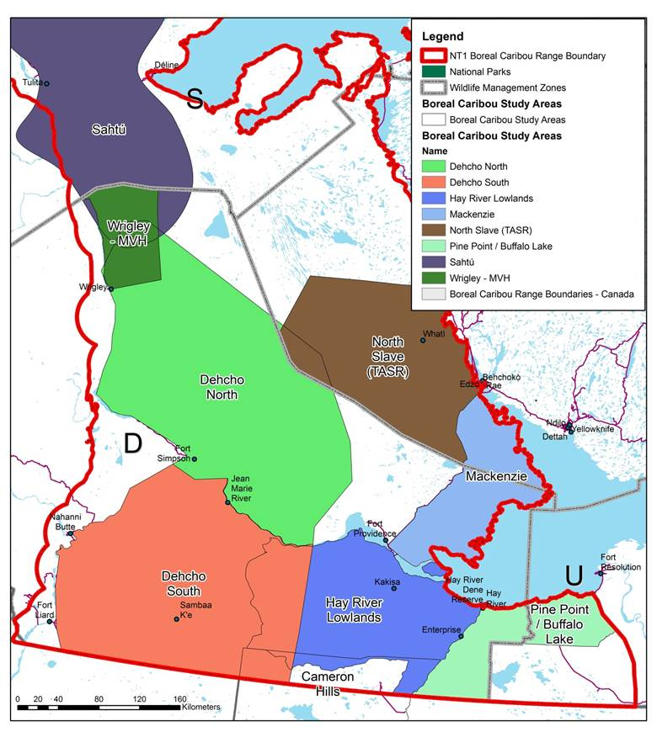
Figure 1. Boreal caribou study areas.

GPS collars will be deployed on up to 23 adult female caribou to monitor the movements, habitat use, survival and responses of these caribou to disturbance in two study areas. Between 20 and 30 collars are required to monitor adult female survival rates and cow:calf ratios in order to provide sufficient statistical power to detect trends over a minimum 5 year period (Rettie 2017), and deployment of 23 collars in the TASR study area will bring the number of collars up to 30. Collar deployments in the TASR study area will ensure at least 10 collars are deployed in the vicinity of the road alignment. Up to 5 collars will be deployed in the North Slave portion of the Mackenzie Study Area.
The collars used in this study are equipped with a “geofencing” function that allows increased frequency of locations to be collected within a previously defined area programmed into the collar. In this study, collars are programmed to generate three locations per day, however this will increase to hourly locations within a buffer of 10 km from the proposed TASR and along HWY 3. This will allow for a finer scale assessment of the behavioural response of boreal caribou to the construction and operation of the TASR, and to traffic along the existing highway. The data will be retrieved via satellite daily or every 3 days depending on time of year. All collars have a breakaway device that drops the collar on the ground at a pre-determined time (e.g. 4 years) so caribou do not need to be recaptured to remove the collar.
Composition / recruitment surveys, to be conducted in March 2021, will provide information on the proportion of calves that have survived their first year (until 10 months of age). After the first year of life, caribou survival is much higher. This information is needed to estimate the population trend (increasing, decreasing, or stable).
For the collaring, a professional capture crew with an experienced helicopter pilot will be employed to conduct the collaring operation. The capture crew (net-gunner and animal handler) will have extensive and current experience net-gunning caribou, collecting biological data and deploying collars. Pursuit of individual caribou will be kept short (≤1 min of running), and will be terminated when the target animal show signs of fatigue (stumbling, open mouth breathing). The net is fired over the caribou, which then usually tangles itself and falls to the ground.
The helicopter lands immediately and two people approach the animal. The legs are hobbled to minimize struggling; the eyes are covered to reduce visual stress; the pulse and breathing rate are visually monitored throughout the handling. The animal is positioned sternally and the head and neck are positioned so that the animal can breathe normally and belch gas from its belly. The capture crew minimizes noise to reduce stress.
Information that will be recorded during capture includes the collar identification number, capture location (latitude and longitude GPS reading using NAD83), group composition and size, duration of chase and handling time, body condition rating, estimated age, presence of a calf, lactation status, animal stress rating, average snow depth and snow condition, and any pertinent information pertaining to observations of the health (check eyes for Besnoitia, other signs of disease, presence of ticks and related hair loss score, previous injury, etc.) of the captured animal, or welfare of other members of the herd from which the caribou is captured;
Females that are judged to be advanced in age will not be collared. Blood, fecal, and hair samples may be collected from as many animals as the opportunity presents. The collar is fastened around the animal’s neck, and the animal is released. Handling generally lasts 10 minutes or less. Once released, the caribou usually springs to its feet and runs off. Post-capture monitoring of the GPS collared animals will be done using location data.
There is inherent risk associated with capturing and handling wildlife. In general, mortalities of caribou can occur at a low rate during net-gunning captures. In the event that an animal is injured during the net-gunning, the handler and net-gunner will assess the injuries. A broken antler would be re-cut with a hand saw to smooth the broken edge. A broken leg or other broken bones will require that the caribou be shot (helicopter will carry a shot-gun). The animal will be dressed in the field and transported to the nearest community so that the meat can be used.
Calf production will be determined by assessing pregnancy rates collected from blood serum during the capture of cows each year of the study and by assessing the movement rates of GPS-collared cows.
Ten-month calf recruitment will be determined from aerial surveys in March 2021. The survey will be conducted by helicopter with a crew consisting of a pilot, a navigator and a classifier who will count and classify the number of calves and adults associated with collared caribou and other caribou observed during the survey. Animals will be classified as calves or adults (≥ 12 months) on the basis of body size. Females will be identified by the presence of a black vulva patch and males by lack thereof. Recruitment will be expressed as the ratio of calves per 100 adult cows.
Pollock et al’s (1989) staggered-entry modification of Kaplan and Meier’s (1958) survivorship model and collared cow data will be used to estimate adult cow survival. For each year, the finite rate of population increase will be estimated from annual recruitment of females (assuming a 50:50 sex ratio in calf production and equal survival of sexes to time of census) and annual adult female survival using the formula outlined by Hatter and Bergerud (1991). The finite rate of population increase (λ) will be determined using a stochastic version of Hatter and Bergerud’s 1991 equation (λ =adult female survival/(1-female calf recruitment) following Latham et al. (2010). The stochastic version of λ is the mean of 10,000 iterations calculating λ.
ENR will follow established protocols and the conditions of the Wildlife Care Committee permit for capture and handling of boreal caribou during collar deployment. Pertinent details of capture and collaring procedures used in previous boreal caribou collar deployment projects for the TASR project include:
- a helicopter with a sliding door on the right hand (pilot) side will be used.
- caribou will be captured with a net-gun and restrained with leg hobbles
- blindfolds will be placed over the eyes to help calm the animal
- animals will be examined to assess condition and to check for capture-related injuries
- samples collected from each animal will include approximately 15 mL of blood from the cephalic vein in the foreleg, approximately 50 g of feces, and a sample of hair with roots taken from the rump
- winter tick hair loss will be documented and associated ticks collected
- score rump body condition (using elk body condition scoring guide)
- record age class based on tooth wear, struggle index, body condition score, capture location, chase and handling times, presence of calf, lactation status, chest and neck girth
- GPS-collars will be snuggly fitted around neck, allowing for an open-palmed had to move freely between neck and the collar material
- blood collected will be analyzed for genetic microsatellites and serum for stress and health assessment, and pregnancy rates
- fecal matter will be analyzed for parasites and genetic microsatellites
If boreal caribou die or need to be euthanized during collaring, additional samples to evaluate age, body condition, and parasites/disease will be collected for analysis. Every effort will be made to bring the meat to the nearest community.

Current Consultation:
The Wildlife Management and Monitoring Plan (WMMP) for the Tłı̨chǫ All-Season Road Project (TASR) underwent several rounds of public review and comment during the Environmental Assessment (EA) and post-EA land use permitting and water licencing phase. Comments were submitted by the Tłı̨chǫ Government, Wek'eezhii Renewable Resources Board (WRRB), Yellowknives Dene First Nation, and North Slave Metis Alliance. The WRRB completed a final review of the WMMP before it was approved by the Minister of ENR. The WMMP underwent its first annual review in September 2020, and comments on the WMMP have been submitted by the WRRB and Tłı̨chǫ Government, as well as by the Wek'eezhii Land and Water Board (WLWB) and Environment and Climate Change Canada (ECCC). An updated version of the WMMP will soon be submitted to the WRRB under as a management proposal under section 12.5.1 of the Tłı̨chǫ̨ Agreement. Copies of this wildlife research permit application will be provided to the Tłı̨chǫ Government, Wek'eezhii Renewable Resources Board (WRRB), Yellowknives Dene First Nation, and North Slave Metis Alliance for review.
Future Community Consultation:
GNWT-ENR and INF will include the results of the composition surveys and GPS-collar deployment in the annual WMMP report (March 31, 2021), and will present the results of the surveys to community representatives from Whati and Behchoko at a future meeting of the TASR corridor working group. There will be a field summary report submitted as a requirement of the research permit, and the results will also be summarized in the first TASR WMMP comprehensive report at the end of the construction phase (March 2022).

Opportunities for Local Participation:
Due to the nature of collaring work, only experienced collaring crews will be used for the collaring. Community observers may be invited to participate in the aerial composition survey, if the crew is able to use an A-Star helicopter, which is a larger machine.

Management or Recovery Plans:
This project is part of the approved Wildlife Management and Monitoring Plan for the TASR.

References
Conference of Management Authorities. 2017. Recovery Strategy for the Boreal Caribou (Rangifer tarandus caribou) in the Northwest Territories. Species at Risk (NWT) Act Management Plan and Recovery Strategy Series. Environment and Natural Resources, Government of the Northwest Territories, Yellowknife, NT. 57 + x pp.
Environment Canada. 2012. Recovery Strategy for the Woodland Caribou (Rangifer tarandus caribou), Boreal population, in Canada. Environment Canada, Ottawa.
MVEIRB (Mackenzie Valley Environmental Impact Review Board). 2018. Report of Environmental Assessment and Reasons for Decision GNWT Tłı̨chǫ All‐Season Road Project EA1617‐01.
Rettie, J.W. 2017. Summary of current and historical boreal caribou population monitoring methods and recommendations for future population monitoring. Report prepared for the National Boreal Caribou Technical Committee. 41pp.

