- Project Title: Marian Watershed Stewardship Program

- Contact Persons: Organization Names: Addresses: Phone/Fax Numbers: Email addresses:
Michael Birlea, Manager, Department of Culture and Lands Protection Tłı̨chǫ Government 127 Donda Tili PO Box 412 Behchokǫ̀, NT. X0E 0Y0 Phone: 867-392-6381 Ext: 1352 Fax: 867-392-6406 Michael.birlea@tlicho.ca
Paul Vecsei, Fisheries Biologist, Department of Culture and Lands Protection Tłı̨chǫ Government 127 Donda Tili PO Box 412 Behchokǫ̀, NT. X0E 0Y0 Phone: 867-392-6381 Ext: 1347 Fax: 867-392-6406 Paul.vecsei@tlicho.ca
- Management Proposal Summary: provide a summary description of your management proposal (350 words or less).
Start Date: July 1, 2023
Projected End Date: April 1, 2027
Duration: 4 years Project Year: 1 of 4
Summary Description: Similar to the TAEMP, the Marian Watershed Stewardship Program (MWSP) is an annual program operating on a 4-year cycle. Each year within the 4-year cycle, a different location within the Marian River corridor is sampled for fish, water and sediment. Results are then stored on our database and accumulated. As of now, we are in the 4th cycle of this program so 3 complete data sets exist for each site. This community-based comparative sampling provides a method to detect and address community concerns related to changes in the environment. The program brings together elders, community members and scientists in an outdoor forum where everyone participates in different aspects of the MWSP. As a mirror program of the TAEMP, each year of the MWSP consists of 3 parts:
- Introductory and planning workshops;
- On-the land camp where samples were collected; and,
- Results workshop

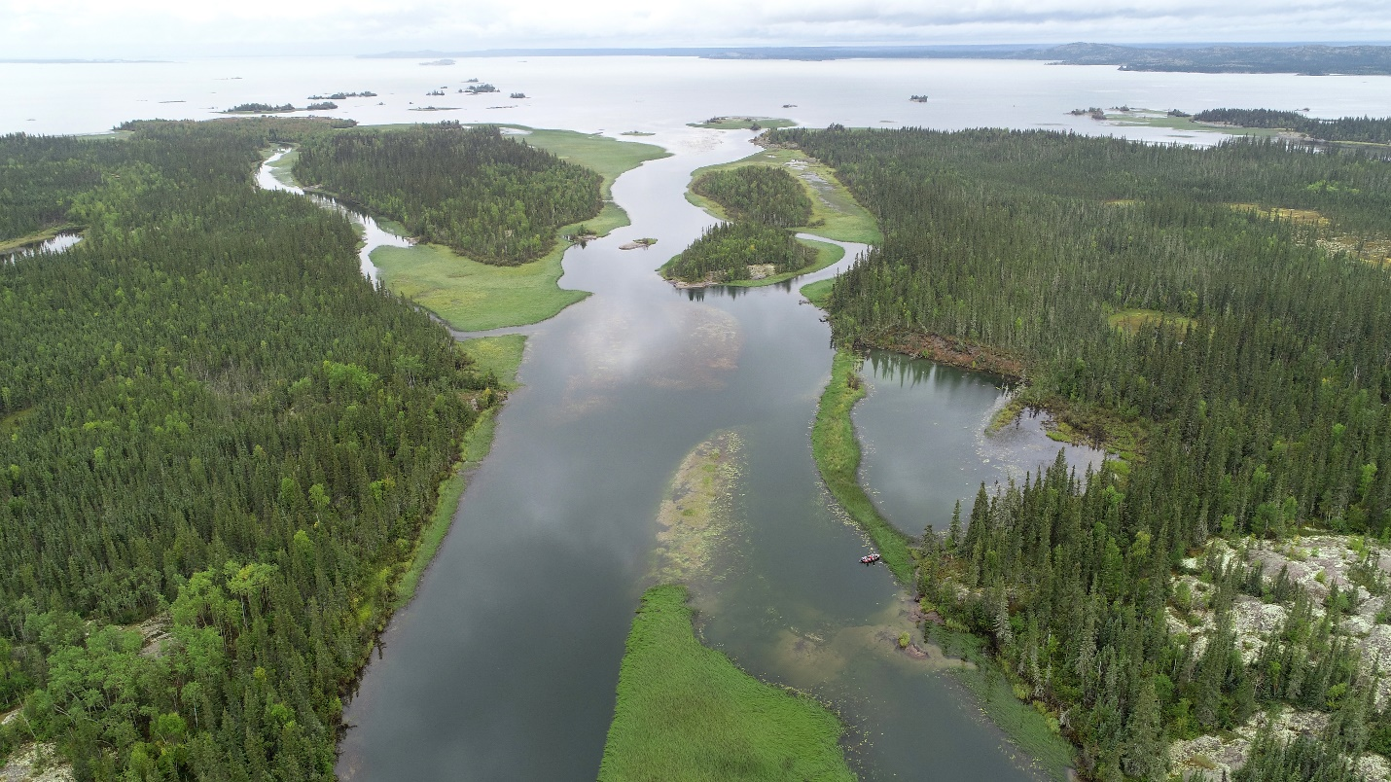
Figure 1. Lower Marian River looking towards Marian Lake

- Background (Provide information on the affected wildlife species and management issue)
Since the Tłı̨chǫ Lands Moratorium was lifted in 2013, development pressure throughout the area known as Wek’èezhìi has grown, and communities were concerned about the impacts of current and future development on their lands. These concerns, particularly those surrounding the potential impacts of the Fortune Minerals NICO project, led to the development of the Marian Watershed Stewardship Program. This community-based aquatic effects monitoring program was designed to collect baseline data at sites prioritized by community members in order to identify the cumulative impacts of development, climate change, and increased use of the Marian Lake watershed. This project is a joint initiative of the Tłı̨chǫ Government (Tłı̨chǫ Ndek’àowo) and key project partners, including the Wek’èezhìi Land and Water Board, Wek’èezhìi Renewable Resource Board, DFO, GNWT-ENR, and AANDC.
Currently, the program is in the repeat comparative sampling phase and sites are being visited and assessed for a fourth time. The MWSP will contribute to the implementation of the NWT Water Stewardship Strategy and Action Plan, and the continuing assessment of contaminant levels in traditional foods. In addition, the MWSP promotes the understanding, and protection of source water for Tłı̨chǫ communities.

The specific objectives of this program are: 1) To design and implement a community-based, regional-scale monitoring program for water quality and aquatic life upstream and downstream of the Fortune NICO site; 2) To build community capacity for these types of monitoring; 3) To collect baseline data prior to possible future operation of the proposed Fortune Minerals mine and to continue this data collection in the future in order to consider cumulative impacts of development, land disturbance, and climate change on water quality (and quantity) in the Marian Watershed; 4) To develop a strong communication plan that will report results back to decision makers (communities, WLWB, Tłı̨chǫ Government, WRRB), CIMP, and other partners in a timely and consistent manner.
Through this community-driven project, the TAEMP is collecting baseline information on fish life history and fish health to discern long-term changes while refining methods to monitor fish that build on both traditional Tłıchǫ knowledge and science. The species of focus varies somewhat based on the geography of the program.
Affected wildlife species: The emphasis during the on-site part of the program is fish. Much time is spent teaching youths about fish life history. In the watersheds where this program operates, there are two life history types exhibited by fish targeted during our monitoring:
1. Riverine: fish that spend their entire lives within the Marian River. This would include Northern Pike and Walleye and some Lake Whitefish.
2. Adfluvial: fish that rear and remain in lacustrine environments for the majority of their life cycle, but that spawn in rivers or streams associated with lakes. This would include Inconnu and most Whitefish caught in the lower portion of the river.
Current threats to fish stocks include pollution from distant sources, climate change, over-fishing and local mining development.
Water quality and sediment sampling are in support of our fish work and can provide important information on the overall health of the ecosystem.
Management issues: Currently, community members have the right to gillnet their fish. This small-scale subsistence fishery is sustainable and does not pose a problem in terms of management of local fish stocks. There was periodic interest from Yellowknife residents to open a guided angling service where clients would have fished in the lower Marian River. TG formally denied the request in a response letter in 2020.

- Consultation and Community Outreach
The MWSP is Tłı̨chǫ run and operated in collaboration with community members primarily from Behchokǫ̀. All samples collected undergo rigorous analysis. Once results become available, we return to the community to report lab results to camp participants and interested community members. Furthermore, we issue periodic MWSP updates on the TG website.
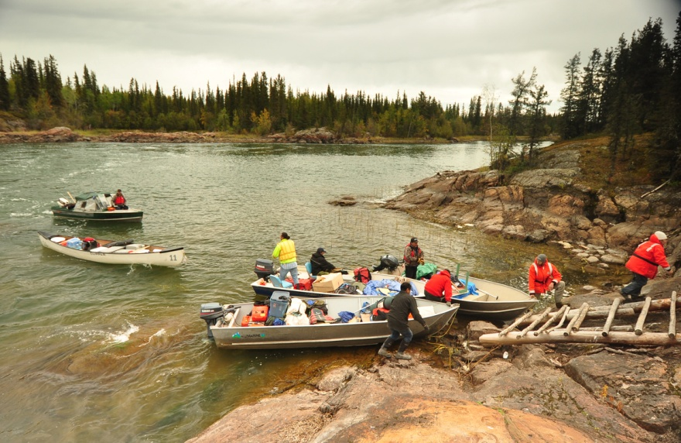
Figure 2. MWSP group prepares to tackle 2nd portage

- Relevant Background Supporting Documentation

Arctic Monitoring and Assessment Program (AMAP). 2011. Arctic Pollution 2011(Mercury). Available at: http://www.amap.no/documents/doc/arctic-pollution-2011-mercury/89
Babaluk, J.A., Sawatzky, C.D., Watkinson, D.A., Tate, D.P., Mochnacz, N.J., and Reist, J.D. 2015. Distributions of fish species within the South Nahanni River watershed, Northwest Territories. Can. Manuscr. Rep. Fish. Aquat. Sci. 3064: vii + 91 p.
Bodaly, R.A., J. W.M. Rudd, R.J.P. Fudge, and C.A. Kelly. 1993. Mercury concentrations in fish related to size of remote Canadian Shield lakes. Can. J. Fish. Aquat. Sci. 50: 980-987.

Cabana, G.A., J.Tremblay, and J.B. Rasmussen. 1994. Pelagic Food-Chain Structure in Ontario Lakes: A Determinant of Mercury Levels in Lake trout (Salvelinus namaycush). Can. Fish. Aquat. Sci. 51:381-389.
Canadian Council of Ministers of the Environment (CCME). 2014. Canadian Environmental Quality Guidelines. Available at: http://ceqg-rcqe.ccme.ca/en/index.html#void
Environment Canada. 2012. Metal Mining Technical Guidance for Environmental Effects Monitoring. Available at: https://www.ec.gc.ca/esee-eem/AEC7C481-D66F-4B9B-BA08-A5DC960CDE5E/COM-1434---Tec-Guide-for-Metal-Mining-Env-Effects-Monitoring_En_02%5B1%5D.pdf.
Government of Northwest Territories Health and Social services (GNWT HSS) 2015. Northwest Territories Nutritional Food Fact Series. Available at: http://www.hss.gov.nt.ca/publications/brochures-fact-sheets/northwest-territories-nutritional-food-fact-sheets-series

Health Canada. 2014a. Canadian Standards (Maximum Levels) for Various Chemical Contaminants in Foods. Available at: http://www.hc-sc.gc.ca/fn-an/securit/chem-chim/contaminants-guidelines-directives-eng.php
Health Canada. 2014b. Guidelines for Canadian Drinking Water Quality - Summary TableAvailable at: http://www.hc-sc.gc.ca/ewh-semt/pubs/water-eau/sum_guide-res_recom/index-eng.php
Health Canada. 2015. Mercury in Fish Questions and Answers. Available at:http://www.hc-sc.gc.ca/fn-an/securit/chem-chim/environ/mercur/merc_fish_qa-poisson_qr-eng.php.
Sawatzky, C.D., D. Michalak, J.D. Reist, T.J. Carmichael, N.E. Mandrak, and L.G. Heuring. 2007. Distributions of freshwater and anadromous fishes from the mainland Northwest Territories, Canada. Can. Manuscr. Rep. Fish. Aquat Sci. 2793: xiv + 239 p.
Scott, W.B. and Crossman, E.J. (1973) Freshwater Fishes of Canada. Bulletin of the Fisheries Research Board of Canada, 184, 966 p.

- Timeline
Each year of the program consists of a summer introductory and planning workshop followed by a fall on-the land camp. The results workshop is typically held in late winter prior to the end of the fiscal year.

