Spill Contingency Plan
Awry Lake Forestry Camp
Awry Lake, NT

Lawrence Lewis
February 2020

TABLE OF CONTENTS
  - General 1
  - Project Description 1
  - Site Description 1
  - Potential Ecological Impacts 2
    - Barren ground caribou 2
    - Species at Risk, COSEWIC Assessed Species 2
    - Archaeological Sites 2
  - Fuel Spill Contingency Plan Purpose and Scope 3
  - Existing Preventative Measures 3
    - Fuel Transport and Storage 3
    - Chemical Use and Storage 4
  - Risk Assessment 4
  - Fuel handling and storage 4
  - Hazardous Materials Stored Onsite 5
  - Potential spill sizes and sources 5
  - Potential Environmental Impacts of a spill (including the worst case scenario) 6
  - Spill Response 8
  - Spill Response Flow Chart 9
  - Spill Response Procedures 10
    - Spills on Land 10
    - Spills on Water 11
    - Spills on Snow and Ice 11
    - Chemical Spills 11
    - Disposal 12
  - Spill Reporting Chain of Responsibility 12
    - The responsibilities of the On-site Camp Manager 12
    - The responsibilities of the Off-site Camp Manager 12
    - Spill Response Team Contact List 13
  - Resources and Training 13
APPENDIX A – Diagrams of Site and Fuel Cache 15
APPENDIX B – Fuel Spill Volumes that trigger NWT Spill Hotline reporting 17
APPENDIX C – NWT Spill Report Form 19
APPENDIX D – Material Safety Data Sheets 21

List of Tables

Table 1. List of hazardous materials found on site, including the storage container type and volume, the volume normally onsite, the maximum volume on site, and its storage location and intended uses 5

Table 2. List of hazardous materials on site, potential discharge events, potential discharge volumes (worst case scenario in brackets), and direction of potential discharge 6

Table 3. Potential environmental impacts of a spill 7

General

This Spill Contingency Plan (the Plan) has been developed for the Awry Lake Forestry Camp (ALFC), located on Awry Lake, at 62 56’X 114 56’. The Forestry Camp is operated by the Department of Environment and Natural Resources (ENR), Government of the Northwest Territories (GNWT). This version of the Plan is effective as of June 1st 2020.

Additional copies of the fuel contingency plan are available onsite. Copies are also kept in the North Slave Regional Office, ENR, in Yellowknife.

Contact information contained in this document should be updated annually.

Project Description
The Awry Lake Forestry Camp (ALFC) functions as a base for short term fire operations usually about 1-2 weeks in duration and was recently used for approximately 2 weeks in the summer of 2019 to house and stage firefighting resources for fires in the area of Awry Lake. The Camp has been upgraded recently and is expected to be in use for many years to come.

Site Description
The ALFC is located approximately 64 km northwest of Yellowknife. It encompasses an area of approximately 1 hectare on the shore of Awry, NT. The camp is located on a flat area of outcrop. There are 7 cabins with bunks, a main building with a full kitchen and dining area for up to 49 people, a shower building, helipads, floatplane/ boat dock and a silo for hazardous goods and fuels. The main building is the only structure wired and powered by a gas generator.

Potential Ecological Impacts

Barren ground caribou
Awry Lake is located within the wintering range of the Bathurst caribou herd. There are no activities at the camp that may potentially disrupt caribou activities using the camp and the camp is not used in the winter months.

Species at Risk, COSEWIC Assessed Species
There are several species listed as “Special Concern” that may occur in the Awry Lake area. These include:
- Short eared owl
- Wolverine
- Peregrine falcon
Every precaution is taken to limit any impact the presence of the camp has on these species, and their habitat.

Archaeological Sites
It is not known if there are any of archaeological sites located in the vicinity of the ALFC.

Fuel Spill Contingency Plan Purpose and Scope
The purpose of the ALFC Fuel Spill Contingency Plan is to provide a plan of action for potential spills that may occur at the camp. The Plan is intended to provide a clear course of action for the camp residents should a fuel spill occur, thus minimizing environmental damage and ensuring maximum safety for camp users. The Plan also clearly describes the chain of responsibility should a spill occur. Communication and reporting procedures are clearly outlined. Both management and field staff should be familiar with the Plan. In addition, it is to be located onsite and accessible, as a reference document.

Existing Preventative Measures
Proper storage and handling of fuels and hazardous materials is the first line of defense for preventing spills and potential impacts to people and the environment. The On and Off-site Camp Managers are required to have up-to-date training in Workplace Hazardous Materials Information System (WHMIS), fuel spill response, and wilderness first aid. A fully equipped Fuel Spill Response Kit is kept on-site in a re-sealable drum adjacent to the fuel shed and near the back gate access to the fuel cache. Contents of the kit are described in section 5.0 Resources and Training.

Fuel Transport and Storage
Fuel required for ALFC is transported to the station via fixed wing aircraft. Drums are moved to a fuel cache in front of the camp. One Insta-Berm portable fuel berms approximately 10’ X 20’ X 12” in size provide secondary containment in the event of leakage.

Fuel used in camp equipment is transferred from drums to plastic gas cans using a
manual pump. When the manual pump is used, absorbent pads are strategically placed so that a minimal amount of fuel escapes into the environment. In addition, absorbent pads are placed underneath the manual pumps when they are in storage to catch any excess fuel that may leak out of the pump apparatus.

Propane is used for the cook stove, hot water heater and fridge. Propane tanks are generally not cached, instead are shipped in when needed on available flights, and placed in the location where they will be utilized.

Chemical Use and Storage
Only a few litres of cleaning supplies are kept onsite. These include household cleaning agents such as dish and laundry detergent, soaps, paint thinner, etc. None of these chemicals present a serious environmental threat should they escape into the environment.
In summary, ALFC is designed to have minimal risk to the environment. As such, the following preventative measures are in place:
    - The area where fuel is cached has secondary containment through the use of One Insta-Berm
    - Drip trays are placed below pumps when stored;
    - Spill kits are located where ever fuel (or motor vehicles) is stored;
    - Absorbent pads are used whenever refueling motorized vehicles to catch any drips;
    - Fuel drums are inspected on a regular basis by the On-site Camp Manager; and,
    - Absorbent pads are wrapped around pipe joints between heating fuel tanks and valves.

Risk Assessment

Fuel handling and storage
The following potential risks have been identified. The probability of spills due to the identified risks is unlikely due to regular inspection of stored fuel, and equipment associated with fuel transfer.
- Leaking fuel drums (bung seals);
- Leaking valves between fuel drums and heaters;
- Leaks, or spills occurring during fuel transfer between storage drums and snowmobiles, aircraft, ATV, pumps, boats, generators, and/or jerry can;
o this could include broken supply pipes, hoses, pumps and associated equipment; and,
- Leakage of propane due to faulty valves.

Hazardous Materials Stored Onsite
Very few hazardous materials is stored onsite, however the fuel cache is located in close proximity of the camp. The volume and location of the fuel cache is included in Table 1. Material Safety Data Sheets (MSDS) for fuels stored onsite are provided in Appendix D.

Table 1. List of hazardous materials found on site, including the storage container type and volume, the volume normally onsite, the maximum volume on site, and its storage location and intended uses.

Material | Storage Container | Normally onsite | Maximum onsite | Storage location and uses
Jet A/ B Fuel | 200L drums | 1000L (5 drums) | 6000L (30 drums) | Located in the fuel cache area. Fuel used for air support to field programs.
Av-Gas | 200L drums | 2 on occasion | 1000L (5 drums) | Located in fuel cache area. Fuel used for air support to  field programs.
Gasoline | 200L drums | 600L (3drums) | 1600L (8 drums) | Stored in the fuel cache area. Some stored in the fuel shed in 5 gallon gerry cans. Used in vehicles such as snowmobiles, ATV, and  outboard motors.
Propane | 45kg cylinders | 135kg  (3cylinders) | 405kg  (9 cylinders) | Stored near buildings where used. For use in kitchen - stove, fridge, water heater.

Potential spill sizes and sources
Table 2 outlines all of the potential spill materials, potential discharge volumes, potential worst case scenarios, and the probable direction of discharge.

Table 2. List of hazardous materials on site, potential discharge events, potential discharge volumes (worst case scenario in brackets), and direction of potential discharge.

Material (sources) | Potential Discharge Event | Discharge volume (worst case) | Direction of potential discharge
Jet A/B (aircraft) | - overfilling of aircraft  - slow leak from storage drums  - large puncture, fast leaking drum  - leak from hose | Likely under 200L Maximum of 6000L (very unlikely) | From fuel storage area, underground seepage into Awry Lake.  From on the water refueling, spill could go  directly into AwryLake.
Av-Gas | - overfilling of aircraft  - slow leak  from drums  - large puncture, fast leaking drum  - leak from hose while filling | Likely under 200L Maximum of 1000L (very unlikely) | From fuel storage area, underground seepage into Awry Lake.  From on the water refueling, spill could go  directly into Awry Lake.
Propane (cooking, heating, refrigeration,) | - slow leak from valve  - puncture of tank (fast leak)  - all drums punctured and leaking at once  - leak while connecting | Likely under 45kg, maximum of 405kg (very unlikely) | In camp near buildings, release into the air (inside or outside  depending where the leak is).
Gasoline (snowmobiles, boat motors, ATV) | - overfilling gas tanks  - slow leak from storage drums  - puncture, fast leaking drum  - leak from hose | Likely under 200L Maximum 1600L (very unlikely) | In camp or in fuel storage area, underground seepage to Awry Lake.

Potential Environmental Impacts of a spill (including the worst case scenario)

The risk presented by the hazardous materials on site is low. During the winter months it is decreased because snow will act as a natural absorbent, and the ice will act as a barrier between the spill material, the ground and Awry Lake. Table 3 provides an assessment of environmental impacts from a spill of hazardous materials including worst case scenarios.

Table 3. Potential environmental impacts of a spill.

Material | Environmental impacts | Worst Case Scenario
Aircraft Fuel (Jet A/B) | If contact is made, Jet A and B are harmful to wildlife and aquatic life. If released into the environment, it has the potential to bioaccumulate, and is slow to biodegrade. | All drums are punctured and fuel is released into the environment, including Awry Lake. Wildlife and aquatic life that comes in contact with spilled fuel are at risk to suffer negative health effects and/or die.
Aircraft Fuel (Av-Gas/100 LL) | When released into the environment, Av-gas has a negative effect on wildlife and aquatic life. It is volatile, and may disperse quickly, but release into water is hazardous to environmental health and safety. | All drums are punctured and all fuel is released into the environment. All fuel makes its way into Awry Lake.
Gasoline | When released into the environment, gasoline has a negative effect on wildlife and aquatic life. It is volatile, and may disperse quickly, but release into water is hazardous to environmental health and safety. | All drums are punctured and all fuel is released into the environment. All fuel makes its way into Awry Lake.
Propane | Propane has the potential to bio- accumulate when released into the environment. It is extremely flammable, therefore its release into the air may be potentially very hazardous. | All cylinders are punctured and all propane is released into the air and environment.

Spill Response
The key personnel involved in spill response include:
Onsite Camp Manager: varies by year
Offsite Camp Manager: Regional Duty Officer (867) 445-3209 (cell);
(867) 767-9238 ext. 53255 (office)

There is usually an on-site satellite phone available for use in case of an emergency. It is located in the main building. In the event of an accidental spill that may cause risk to human health and safety, or may cause serious damage to the environment, this satellite phone will be used. In addition, the ALFC has an FM radio Base station connecting personnel with aircraft or ground personnel away from the camp in case of an emergency.

Following the identification or reporting of a spill to the On-site Camp Manager, the next action will be to report the spill to the 24 hour NWT Spill Hotline. The On-site Camp Manager will inform the Regional Duty Officer (located in Yellowknife) who will notify the requisite inspectors as necessary.

All public or media enquiries are to be made to the Regional Duty Officer, Department of Environment and Natural Resources, GNWT, Yellowknife.


Major spill (over guideline levels)
Minor spill (under guideline levels)
Notify On-Site Camp Manager via two-way radio (carried by all personnel working in the field (away from the camp area)
Notify NWT 24 hr. spill report line at 867-920-8130
Notify Regional Duty Officer (867) 445-9165
(867) 767-9238 x.53255

Spill Response Flow Chart
Spill is identified by personnel at camp

Identify type and approximate quantity of product spilled
Determine risk to human health and safety

Ensure spill does not enter water bodies
If safety permits: stop spill
Ensure spill does not enter water bodies
If safety permits: stop spill

Keep track of spills in camp database, and report spills to inspectors upon visitation to the site, or within a set timeframe

Recover as much fuel as possible

Spill Response Procedures
Fuel spill response equipment is contained a re-sealable metal drum adjacent to the fuel shed and back gate access to the fuel cache (contents listed in s. 5.0 Resources and Training).
Additional absorbent fuel spill pads are stored in the fuel shed.

See Spill Response Flow Chart (s 4.1) for process to follow if and when a spill occurs. Detail actions are provided below:

Spills on Land
Steps to follow if a spill on land is identified:
  - identify the source of the leak or spill;
  - contain the spill at the source if possible;
  - stop a leak from a barrel;
  - cease filling operations if leaking vessel is receiving fuel;
  - check valves and seals, and ceasing use of these valves if leaking;
  - transfer all fuels from leaking barrels; and,
  - place plastic sheeting at the foot of the leak to minimize seepage of the spilled material to the environment.

Spills on land can be contained and cleaned up by the following methods:
- place a soil berm down slope of the running or seeping fuel;
- place plastic tarps at the foot of and over the berm to permit the fuel to pool on the plastic for easy capture. Berms can be made of snow and lined with plastic in the winter;
- use absorbent mats to soak up the fuel. The fuel can be squeezed from the mats into re-sealable metal drums or plastic pails, and the pads can
then be re-used;
- Larger pools of fuel can be pumped into empty drums. It is especially important to prevent fuel from entering a body of water where it will have a greater environmental impact;
- place a light covering of Sphag Sorb or alternate absorbent material onto soil or vegetation to absorb films of petroleum products; and,

- place contaminated absorbent mats into metal or plastic containers for eventual disposal by incineration and place used Sphag Sorb, vegetation and/or soil into a metal re-sealable drum or plastic container for eventual transport and disposal in Yellowknife.

Spills on Water
Implementing the following steps can control spills of petroleum products on water:
- deploy floating boom(s) to contain the floating product;
- use a skimmer once a boom has been secured to capture the spilled product, and then pump it through hoses to empty fuel drums; and,
- use absorbent mats or similar materials to capture small spills on water.

Spills on Snow and Ice
Spills on snow and/or ice can be contained and cleaned up by the following methods:
  - construct a snow berm, lined with plastic sheeting, around the edge of the spill; and
  - shovel and scrape contaminated snow and ice and placing them into re-sealable metal drums or on plastic and within plastic lined berms on land.

Chemical Spills
The effects of chemical spills can be reduced by the following methods:
- apply absorbents to soak up liquids;
- place plastic sheeting over solid chemicals, such as dusts and powders, to prevent their disbursement by wind or investigation by birds or other wildlife; and
- neutralize acids or caustics by placing spilled material and contaminated cleanup supplies in an empty refuge drum and seal for disposal.

Disposal
Any contaminated soil and/or vegetation will be placed on impermeable material and burned. All remaining soil/vegetation will be placed in bags or re-sealable metal drums (at least 3 onsite at any one time) and flown to Yellowknife for appropriate disposal. All fuel soaked absorbent material will be incinerated.

Spill Reporting Chain of Responsibility

The responsibilities of the On-site Camp Manager

  - Assume authority over the spill area and personnel involved;
  - Initiate the Spill Contingency Plan;
  - Evaluate and assess the magnitude of the spill (see Appendix B for reporting requirements related to spill size);
  - If necessary, report the spill to the NWT 24-hour Spill Report Line at (867) 920-8130;
    - Provide information such as:
      - location of the spill;
      - direction of flow (if any);
      - type and volume of material spilled;
      - cause of spill;
      - date and time of spill; and,
      - any perceived threat to human health and/or the environment.
  - Develop an overall plan of action; and,
  - Report to the Off-site Camp Manager and provide recommendations on resource requirements (additional manpower, equipment, material, etc.) to complete the cleanup effort.

The responsibilities of the Off-site Camp Manager
  - If needed, organize additional spill response, and clean-up resources;
  - If needed, act as liaison with other government agencies as well as the public and the media;
  - Ensure that the correct documentation of the spill, and the cause of the spill the cause of the spill is properly documented (see Appendix C for NWT Spill

Form), monitor the effectiveness of the cleanup effort, and oversee the implementation of appropriate measures to prevent a recurrence of the spill;
  - ensure that follow-up documentation required by appropriate regulators is prepared and submitted; and,
  - ensure that the spill is cleaned up and all follow-up communication and reports are filed with Environment Division, ENR, GNWT in Yellowknife.

Spill Response Team Contact List

ENR Contact List
Lawrence Lewis  – Regional Manager of Operations | (867)446-2915 cell  (867) 767-9237 ext., 53238 office
Bruno Croft  – North Slave Regional Superintendent, ENR, GNWT | (867) 767-9238 ext. 53234
NWT Spill Hotline | (867) 920-8130

The Department of Lands Inspector will be the lead enforcement agency for all spills at Francois Lake (contact below)

Clint Ambrose
Manager, Resource Management (Inspector)
North Slave Regional Office
Department of Lands
Government of Northwest Territories
140 Bristol Avenue, Yellowknife, NT X1A 3T2
Cell: (867) 446-0769 / Tel: (867) 767-9188
Email: clint_ambrose@gov.nt.ca
Web: www.lands.gov.nt.ca

Resources and Training
A Fuel Spill Response Kit is located adjacent to the fuel shed by the back access gate to the fuel cache site. The contents of the Kit include:
    - 1 Safety goggles
    - 1 Danger "no smoking" sign
    - 1 coverall suit (Size 3XL)
    - 1 Pair polyvinyl chloride gloves
    - 1 tube composite sealant
    - 2 Lrg orange Heavy Duty bags (to store used materials)
    - 2, 10 ft. absorbing boom/pads/for use on water
    - 8, 4 ft. absorbing sock pads (white – repels water)
    - Approximately ~ 200 absorbing pads (white – repels water)) The following training is required for On -site Camp Managers:
WHMIS certification which meets the Canadian Occupational Health and Safety Regulations (available online https://worksitesafety.ca/product-category/online-training/?fwp_product_cat_facet=canada-online-training)

    - Wilderness First Aid certification

    - Fuel Spill Response

The latter two courses are most often taken through a local company in Yellowknife, Arctic Response, which provides workplace training courses in a variety of areas.

APPENDIX A – Diagrams of Site and Fuel Cache

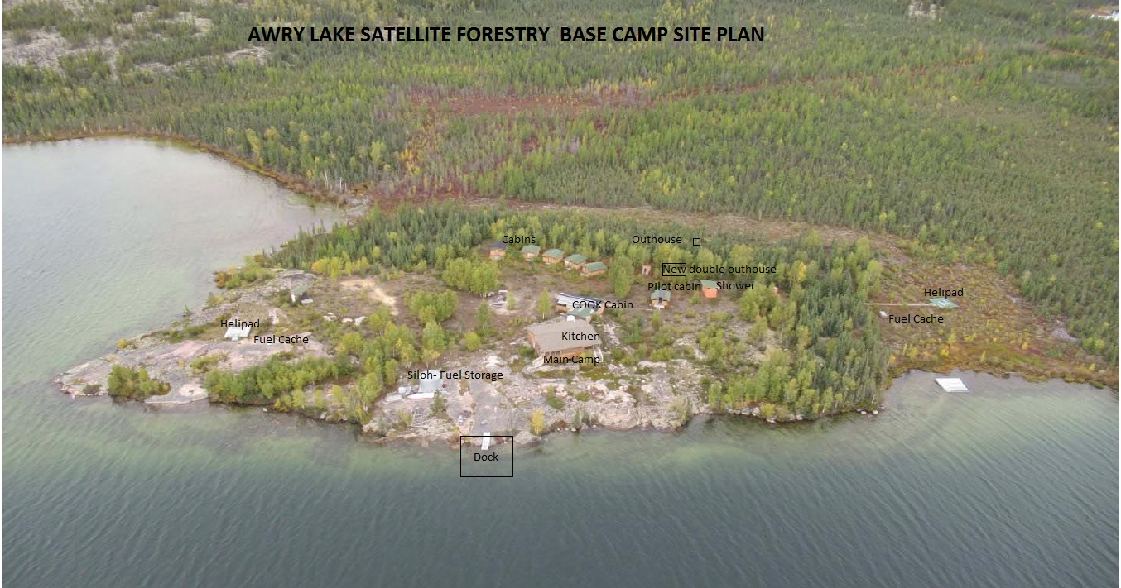
Spill Kit*

- Figure 1 - Drawing depicting a) the placement of the land use permit area, camp and fuel cache, silo where fuels and hazardous materials are stored. Added drawings not to scale.

APPENDIX B – Fuel Spill Volumes that trigger NWT Spill Hotline reporting

Note: L = litre; kg = kilogram; PCB = Polychlorinated Biphenyls; ppm = parts per million

Substance | Reportable Quantity | TDG  Class
Explosives |  | 1.0  2.3/2.4  6.2  6.2  7.0  None
Compressed gas (toxic/corrosive) |  | 1.0  2.3/2.4  6.2  6.2  7.0  None
Infectious substances  Sewage and Wastewater (unless otherwise authorized) | Any amount | 1.0  2.3/2.4  6.2  6.2  7.0  None
Radioactive materials |  | 1.0  2.3/2.4  6.2  6.2  7.0  None
Unknown substance |  | 1.0  2.3/2.4  6.2  6.2  7.0  None
Compressed gas (Flammable)  Compressed gas (Non-corrosive, non-flammable) | Any amount of gas from containers with a capacity greater than 100L | 2.1  2.2
Flammable liquid | ≥100 L | 3.1/3.2/3.3
Flammable solid |  | 4.1
Substances liable to spontaneous combustion | ≥ 25 kg | 4.2
Water reactant substances |  | 4.3
Oxidizing substances | ≥ 50 L or 50 kg | 5.1
Organic peroxides |  | 5.2
Environmentally hazardous substances intended for | ≥1 L or 1 kg
disposal |  | 9.0
Toxic substances | ≥ 5 L or 5 kg | 6.1
Corrosive substances |  | 8.0
Miscellaneous products, substances or organisms |  | 9.0
PCB mixtures of 5 or more ppm | ≥ 0.5 L or 0.5 kg | 9.0
Other contaminants--for example, crude oil, drilling fluid, produced water, waste or spent chemicals, used or waste oil, vehicle fluids, wastewater. | ≥ 100 L or 100 kg | None
Sour natural gas (i.e., contains H2S) Sweet natural gas | Uncontrolled release or sustained flow of 10 minutes or more | None
 | ≥ 20 L
Flammable liquid | When released on a frozen water | 3.1/3.2/3.3
Vehicle fluid | body that is being used as a | None
 | working surface
Reported releases or potential releases of any size that: are near or in an open water body;
are near or in a designated sensitive environment or habitat;
Pose an imminent threat to human health or safety; or Pose an imminent threat to a listed species at risk or its critical habitat

APPENDIX C – NWT Spill Report Form

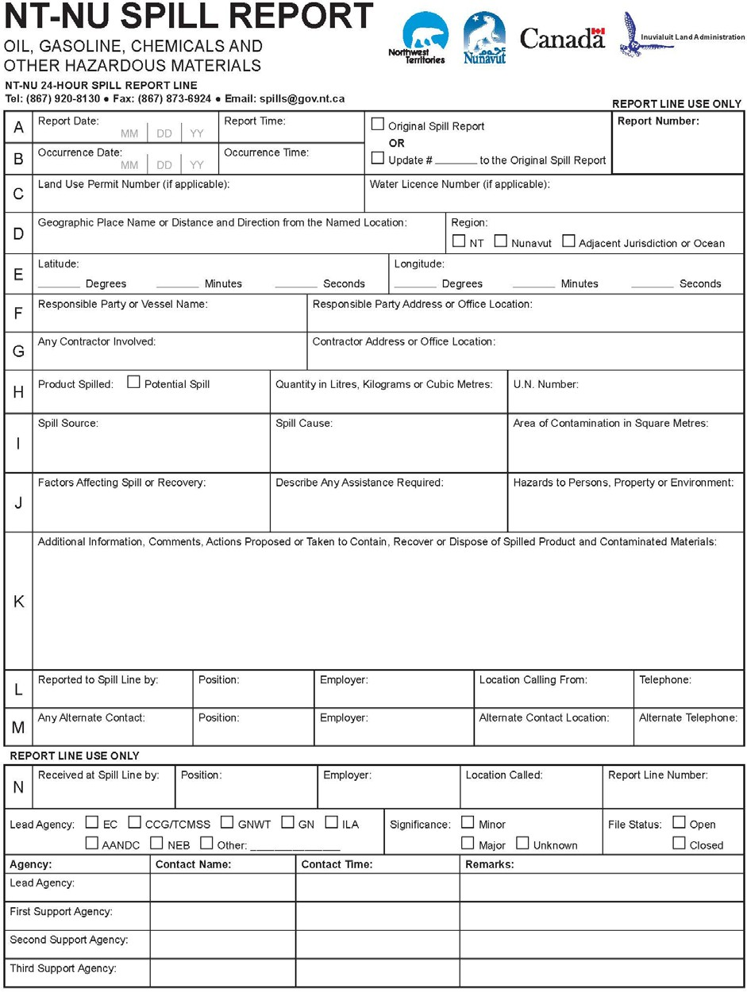

APPENDIX D – Material Safety Data Sheets

