Waste Management Plan Awry Lake Forestry Camp

Awry Lake, NT

February 2020

1.0 Sources and Management of Waste at the Awry Lake Forestry Camp

The Awry Lake Forestry Camp (ALFC), location 62 56”31 X 114 56” 26’, on Awry Lake, NWT, would may be occupied on an annual basis from early June until early September. During this time, the camp would be operational about 2-14 days on average for the entire year and the number of residents would vary from 4 to 49. For the past 10 years the camp has mainly been populated by a small (~4-10) group of firefighters to do maintenance of the camp. ENR Policies guide operational endeavors to be as clean as possible with respect to waste storage and disposal. Back hauls are used whenever possible to remove waste from the site and continuous monitoring of camp facilities by camp staff will ensure these policies are adhered to. Wildlife Officers or a Camp Manager typically supervise the operations of the camps and employ preventative measures to not attract problem wildlife to the site by temporary storing garbage in buildings and removing food wastes from the camp on a regular basis. They monitor the waste coming from the camp and ensure the proper safeguards are in place to prevent waste from adversely affect the environment. The effective date of this Waste Management plan would be June 1st, 2020.
In general, the ALFC does not produce a large quantity of waste. However, the waste that is produced is dealt with in the following ways:

Table 1 - Outline of the waste types produced at FLFC, their source, temporary storage, and disposal.
Waste Type | Source and daily amount | Storage | Disposal
Kitchen waste | Food preparation etc. 40lbs/day | - Packaging from meat products, other food contaminated waste, non-recyclable plastics, are stored in an airtight garbage container in the storage tent until it can be shipped to YK.  - paper, cardboard, boxboard are separated and stored in the kitchen and storage tents  - plastic, tin, glass, aluminum, tetrapaks and other recyclable goods are cleaned and stored in the kitchen tent.  - Compost is separated from other kitchen wastes  and stored in plastic (airtight) buckets  in a storage tent. | - Packaging from meat products, other food contaminated waste, non-recyclable plastics, shipped to Yellowknife (YK) for disposal in the landfill.  •paper, cardboard, boxboard are stored for shipment to YK and disposal at recycling depot but may be burned with scrap wood onsite in a modified burn barrel. Ashes are hauled to YK for disposal.  - Recyclable goods (plastics, tin, glass, aluminum, tetrapaks) are always shipped to YK and taken to recycling depots.  - compost is  shipped to YK for

 |  |  | disposal at the YK community garden compost.
Grey Water | Wash tent, kitchen tent estimated gross 1000L/ Day at full capacity | Grey water is pumped to a sump  located behind the kitchen about 50m from the nearest high water mark | Grey water filters through the soil over time.
Sewage etc | Human waste estimated 5L/ Day at full capacity | FLFC is equipped with 4 pit latrines. We are considering the purchase of at least one incinerating toilet. | Pits are treated with Lime
Hazardous materials | Fuel supplies,  Estimated waste fuel is negligible | Empty fuel drums/propane tanks etc. are stored onsite. Absorbent pads etc. used for minor spill cleanup are stored in a bucket in the  fuel shed. | Empty drums/tanks are hauled back to YK as soon as possible (not left onsite over the winter).  Contaminated materials (absorbent pads) are shipped back to YK for appropriate disposal

- Contact Information

ENR Contact List

Lawrence Lewis
– Regional Manager of Operations, ENR, GNWT (867) 767-9238 ext., 53238

Bruno Croft
– North Slave Regional Superintendent, ENR, GNWT (867) 767-9238 ext. 53234

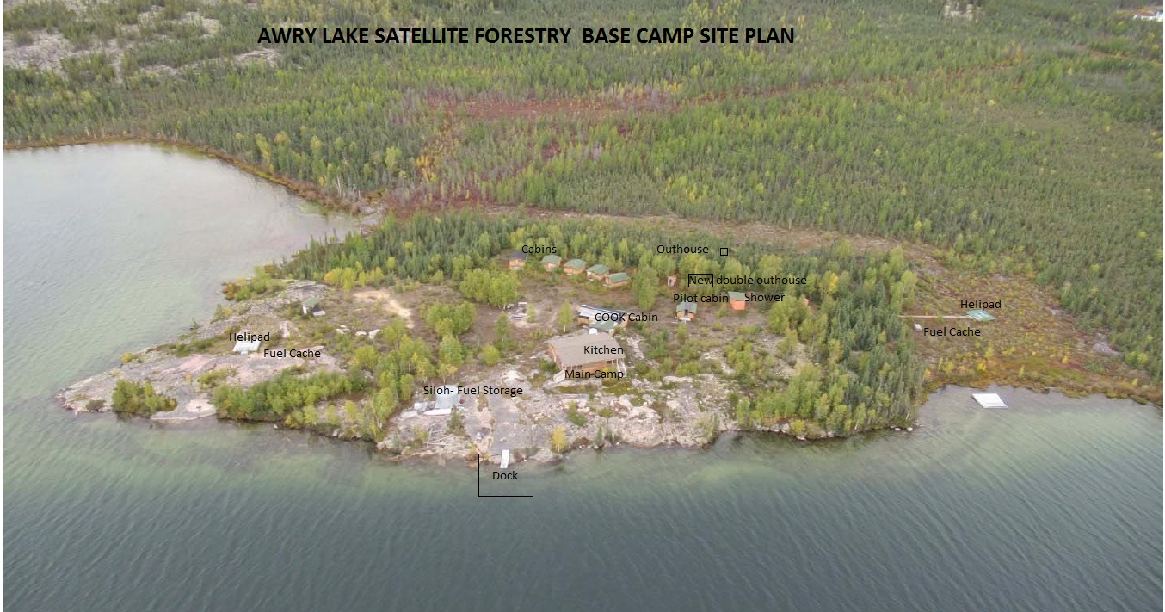
Grey water sump

